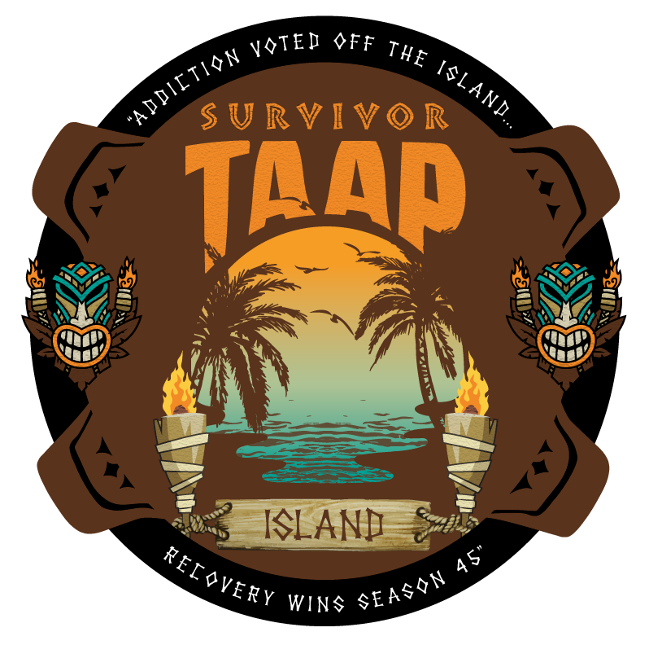

Golf Tournament & Pre-Conference Wednesday, September 4, 2019

Revised 7/17/19

7th Annual TAAP Golf Tournament 45th Annual State TAAP Conference

TIME | EVENT | LOCATION
7:00am | Golf Breakfast  Event Sponsor: Eudaimonia  Lunch Sponsor: Creekview Counseling  Breakfast Sponsor: Arbor Treatment  Golf Ball Sponsor: The Last Resort  Beverage Sponsor: La Hacienda | Lone Oak Terrace
7:00am | Golf Registration | Lone Oak Terrace
8:00am | Golf Shotgun Start | Hill Country Golf Course
Noon | Golf Lunch | Uvalde Ballroom
11:00am | Pre Conference/Registration Opens | TBD
11:30-1:30pm | Lunch: Lunch Trucks  Featured Workshop 1: (1.5 CEUs)  “Surviving Trial and Error: A Creative Modality for Resolving Ethical Dilemmas in Addiction Counseling”  Stacy Speedlin and Helon Belton | Independence 6-7
12:00-1:30pm | Golf Luncheon and Awards Ceremony | Antler’s Restaurant
1:30-2:00pm | BREAK
2:00-3:30pm | Featured Workshop 2: HIV (1.5 CEUs)  HIV/AIDS: It’s a Whole New Ballgame – Part I  Larry Diaz | Independence 6 & 7
3:30-4:00pm | BEVERAGE BREAK  Sponsored by: Sage Recovery | Independence 6 & 7
4:00-5:30pm | Featured Workshop 3: HIV (1.5 CEUs)  HIV/AIDS: It’s a Whole New Ballgame – Part II  Larry Diaz | Independence 6-7
5:00-7:00pm | Conference Registration Open | Independence Lobby
5:00-8:00pm | Exhibitor & Sponsor Set Up | Independence & Adjacent Lobby Space
5:30-7:00pm | E&S Private Reception  Sponsored by: | Independence 1

Conference Day One Thursday, September 5, 2019

Time | Sessions  & CEUs | Hill Cty  E | Hill Cty F | Hill Cty  G | Indy 1 | Indy 2 | Indy 3 | Indy 4 | Indy 5 | Indy 6 | Indy 7 | Indy 8 | NOTES
Set Up |  | Rounds 120 | Rounds 120 | Rounds 120 | See Schematic | Rounds 90 | See Schematic | Rounds | Rounds | Rounds 90 | Rounds 90
8:00 | Registration Opens  Exhibits Open |  |  |  | Bookstore  &  Cyber Cafe |  | Conference Office & AV Storage |  |  | PREVENTION  FOCUS | CRIM JUSTICE  FOCUS | The Heart Room
8:00 | Continental Bkfst.  Sponsored by:  Addiction Campuses
8:45 |  |  |  |  |  |  |  | Opening | Ceremony
9:00 | Featured Keynote (1.5) |  |  |  |  |  |  | KEYNOTE  “High Intensity Drug  Trafficking  Areas” | Michael McDaniel  Sponsored by:  HIDTA & ONDCP
10:30 | All Day Coffee Break  Sponsored by:  Kyle ER & Hospital
11:00 | Individual Sessions (1.5) | “Digital Tools For Prevention, Treatment and Recovery”  Eluterio Blanco | “Focusing on Process-Solving vs Problem-Solving in Client Care”  David Henderson | “Updates on TCBs Certification/Peer Medicaid Certification”  Frank Davis |  | “Introduction to Trauma Informed Care and Addiction Services”  Christopher Townsend |  | Lunch | Set Up | “Strategic Prevention Framework-Facilitation Skills for Professionals”  Mitchell Moore | “Yikes I’ve Been Arrested for DWI and Possession. Now What?”  Tricia Sapp
12:30 | Lunch:  Option 1: On Your Own  Option 2: Lunch-n-Learn (1.5)  Sponsored by: SARC |  |  |  |  |  |  | LUNCH-N-LEARN  “Town Hall Meeting & State of the Profession” | Cynthia Touhy  John Cates  Sherri Layton
2:00 | Break
2:30 | Individual Sessions (1.5) | “Striving for Better Outcomes Using Transformative Treatment”  Kay Baker | “ Supervision”  Kimberly Fair | “Evidence Based Research: How do You Get There?”  Robert Landry |  | “Mindfulness and Acceptance -Based Tx Approaches”  Sonia Roschelli |  | Event | Set Up | “What About the Children? Hurt, Hope & Healing for Children and Youth of Addicted Parents”  Cathey Brown | “Your Future as a Behavioral Health Business Development Professional and Ethicals”  Carrie Hunnicutt
4:00 | Refreshment Break  and |  |  |  |  |  |  | Sponsored by: | Reccovery  Unplugged
4:30 | Special General Session (1.5) |  |  |  |  |  |  | “Music is Medicine:  A Concert” | Joseph Gorordo
6:00 | Break
6:15  7:45 | Individual Sessions (1.5)  End of Day | “Resistance versus Non-Compliance in Treatment”  Brandy Klingman | “Starting at the Beginning: Case Conceptualization of the Whole Person”  Lolly Wool | “Navigating Through the Pain: Working with Addiction Clients that Self-Injure”  Jennifer See |  | ”Stress Management”  Scott Rheinschmidt- |  |  |  | “Community Coalitions: Members Taking it to the Next Level Creating Long Term Change”  Boyd Baxter | “Managing ‘Resistance’ in Criminal Justice Populations”  Brittany Proctor
Sponsors & Exhibitor Booths: Hill Country East Lobby, Independence Lobby & Windmill Foyer Registration/Information: Independence Lobby AA Meeting: 9-10PM Brady Meeting Room
TOTAL CEUS: 9 TOTAL WORKSHOPS: 21

Conference Day Two Friday, September 6, 2019

Time | Sessions  & CEUs | Hill E | Hill F | Hill G | Indy 1 | Indy 2 | Indy 3 | Indy 4 | Indy 5 |  | Indy 6 | Indy 7 | Indy 8 | NOTES
Set Up |  | Rounds  120 | Rounds  120 | Rounds  120 | See Schematic | Rounds  90 | See Schematic | Rounds | 880 |  | Rounds  90 | Rounds  90 | Rounds  90
8:00 | Registration Opens  Exhibits Open |  |  |  | Bookstore  &  Cyber Cafe |  | Conference Office & AV Storage |  |  |  | PREVENTION  FOCUS | CRIM JUSTICE  FOCUS | The Heart Room
8:00 | Continental Bkfst.  Sponsored by:  The Lovett Center
8:45 |  |  |  |  |  |  |  | Housekeeping
9:00 | Featured Keynote (1.5) |  |  |  |  |  |  | KEYNOTE  “Battling the Opioid Crisis” | UT HEROES Program  Sponsored by:  UT Health Science Ctr. of Houston
10:30 | All Day Coffee Break  Sponsored by:  BRC Recovery
11:00 | Individual Sessions (1.5) | “Creating Community and Connection in a Web World”  Joni Ogle | “The Neuroscience and Genetics of Addiction”  Crystal Collier | “Protecting Our Youth from Marijuana”  Nichole Holt |  | “Romancing the Brain-  Pari I”  Cynthia Moreno Touhy |  | Luncheon | Set Up |  | “It All Starts Here: Prevention and Team Building”  Lisa Reiling | “Marketing Tips and Tricks for Building Your Business”  Adrien Paczosa
12:30 | Break
12:45 | Awards Luncheon  (2.0)  Emcee Sponsor;  Summer Sky  Speaker Sponsor:  Transformations |  |  |  |  |  |  | Awards  Luncheon  Sponsored by:  Taylor Recovery | Emcee:  Neil Scott  Guest Speaker
2:45 | Break
3:00 | Individual Sessions (1.5) | “ACEs: The Implications for Addiction…So What Now?”  Clara Contreras | “Food and Mood: When Food and Eating is a Problem in Life”  Ralph Carson | “Working with Hope and Despair in Addiction Treatment”  Robert Hilliker |  | “Romancing the Brain-  Pari II”  Cynthia Moreno Touhy |  | “Ethics and Compliance: Me, You and Us”  Maeve O’Neil |  |  | Social “Determinants of Mental Health”  Julie Stevens | “Anger Management Reimagined with Incarcerated Clients”  Tina Huseth
4:30 | Door Prize Refreshment Bk  Sponsored by:  Laurel Ridge
5:00 | Individual Sessions (1.5) | “Play is Important Work”  Elizabeth Devine | “Recognizing Triggers and Changing Narratives”  Noreen Graf | “Understanding Sex Addiction and Compulsion”  Dennis Hall |  | “Treatment with Medication Assisted: A Winning Combination”  Peter Mott- |  | "Action Methods for Resolving Past Loss and Unresolved Hurts"  Gary Butler |  |  | “Powdered Alcohol”  Nichole Holt | “Successful Reintegration: Create a Re-Entry Program in Your County Jail”  Jamie Schmitt
6:30 | End of Day
Sponsors & Exhibitor Booths: Hill Country East Lobby, Independence Lobby & Windmill Foyer Registration/Information: Independence Lobby AA Meeting: 9-10PM Brady Meeting Room
TOTAL CEUS: 8 TOTAL WORKSHOPS: 20

Conference Day Three Saturday, September 7, 2019

Time | Sessions  & CEUs | Hill Cty  E | Hill Cty F | Hill Cty  G | Indy 1 | Indy 2 | Indy 3 | Indy 4 | Indy 5 | Indy 6 | Indy 7 | Indy 8 | NOTES
Set Up |  | Rounds  120 | Rounds  120 | Rounds  120 | See  Schematic | Rounds  90 | See Schematic | Rounds | Rounds | Rounds  90 | Rounds  90 | Rounds  90
8:00 | Registration Opens  Exhibits Open |  |  |  | Bookstore &  Cyber Cafe | Recovery Support Specialist Focus | Conference Office & AV Storage
8:15 | Continental Bkfst.  Sponsored by:
9:00 | Featured Keynote (1.5) |  |  |  |  |  |  | KEYNOTE  “Opiates, the Future and NSSI”  Lori Vann | Sponsored by:  Paradigm Treatment Centers in Malibu
10:30 | All Day Coffee Break  Sponsored by:  Kemah Palms & Cypress Lakes Lodge
11:00 | Individual Sessions (1.5) | “Understanding and Treating Chronic Pain and Addiction”  James Flowers- | “The Human Faces of Recovery: Past, Present, Future”  Thomas McGovern | Set Up |  | “Mental Health and Reentry Peer Support”  Sandra Smith |  | “HIV & STIs: New Approaches for Improving Outcomes – Part I”  Vanessa Favela |  | “The Human Trafficking Trifecta: Drugs, Sexual Exploitation and Trauma”  Shani Bacy | “Money Talks: Exploring Financial Health in Recovery”  Alycia DeGraff | “Supervision”  Eric Schmidt | State TAAP BOD Meeting  Bandera Room
12:30 | Lunch on Your Own |  |  | Peer Recovery/  Recovery  Coach/CI Lunch  1.5 CEU
2:00 | Individual Sessions (1.5) | “Pillars: Resiliency for Survival”  Whitney Anderson | “Numbing the Pain: Suicide and SUD”  Zandra Ellis |  |  | “Ethics of PRS”  Jana Magee |  | “HIV & STIs: New Approaches for Improving Outcomes – Part II”  Vanessa Favela |  | “The Survivor Slot Machine”  (Gambling Addiction)  Milton Ayala | “Complex Trauma: Preparing the Clinical Team”  Anette Martinez | “Marijuana- the Conflict Between Sobriety vs Society”  Baqui Martin | TCBAP Board Meeting  Bandera Room
3:30 | End of Day
Sponsors & Exhibitor Booths: Hill Country East Lobby, Independence Lobby & Windmill Foyer Registration/Information: Independence Lobby AA Meeting: 9-10PM Brady Meeting Room
TOTAL CEUS: 6 TOTAL WORKSHOPS: 13

